Intro: Tell us more about yourself?

What’s Good everyone my name is Amo and i go by the stage name Mighty and I’m happy to be here!

Tell us about yourself:

I’m a musician, born and raised in Soweto. That hood really thought me everything i know. The man you seeing here today is a product straight from Soweto. So my schooling history starts at Tshepisong primary, i did my high school at Tulip combined school which is in rooderport and that’s where i matriculated. 2018 was when i moved to Pretoria mainly to further push my university studies but ended up taking a Gap year that year and later enrolled with tuks. This was back in 2019 and here I am today.

Q.1If you were stranded at an island, which 3 of your favourite songs would you bring with and why?

Answer: firstly I would go with a hip hop song by Nasty C, titled ‘Hard choices’. This currently my favourite song and I feel like it always puts me in a good mood every time I hear it. So being stranded and listening to this song would make the situation I’m in less stressful.

<https://youtu.be/JNZcrv2MmBI?si=pevQpU9kg5xvG1ik>

My second choice is a very old song by Jay Z , titled ‘U don’t know’ . This one is to boost my confidence when things get hard. I feel like Jay Z is one of those people who can really push you to achieve great things and build your character solely through music. Maintaining your confidence even when you going through troubles say a lot about your character.

<https://youtu.be/9FnEyTb5dcQ?si=aDpKLnGUbYpzCIY>

You know what they say about save the best for last right? Yeah my last pick would definitely be a gospel song by Hlengiwe titled ‘living waters’. You know sometimes when you are having hardships in your life, the only person you can truly turn to is the Lord. There’s a scripture that says Psalm 55:22 cast all your burdens unto the Lord and he will sustain you. (Psalm 55:22) so this song really adjusts my inner spiritual self.

<https://youtu.be/6YBiaclB1cc?si=biBfkvL-Vk1VqrLO>

Q2. Which book would you come with and why?

The power of now by Tolle. This is book is a guide to spiritual enlightenment. It talks about living in the moment and being in control of your thoughts and emotions. So if I was to get stranded on an Island I feel like that book would really keep me going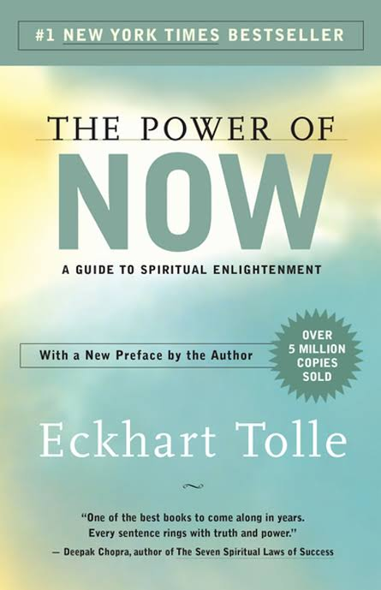

Q3. If you were to pick any luxury item, which item would it be and why?

My Phone. A phone is entertaining and it reduces stress. You can literally connect with anyone around the world with this tool. So you can never get stranded if you think about it

